5/10/2017

Author: Ryan Breau

**SWTS1104 V.1.3**

**Puzzle and Dragons Database**

**Software Requirements Specification Document**

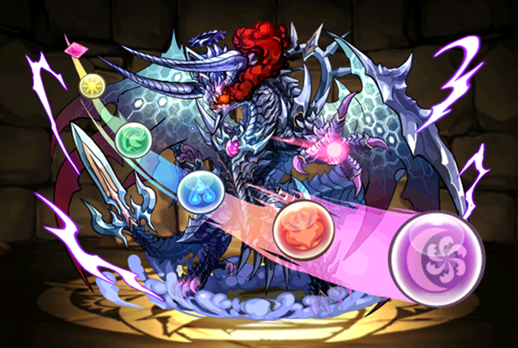

**Table of Contents**

Revision History 4

1. Introduction 5

1.1 Purpose 5

1.2 Scope 5

1.3 Game Knowledge 5

1.3.1 Monsters 5

1.3.1.1 Monster ID 6

1.3.1.2 Rarity 6

1.3.1.3 Monster Name 6

1.3.1.4 Monster Types 6

1.3.1.5 Awoken Skills 6

1.3.1.6 Monster Stats 7

1.3.1.7 Current Level 7

1.3.1.8 Max Level 7

1.3.1.9 Team Cost 7

1.3.1.10 + Stats 7

1.3.1.11 Active Skill 8

1.3.1.12 Leader Skill 8

1.3.1.13 Attributes 8

1.3.2 Player 8

1.3.2.1 Player Name 9

1.3.2.2 Starting Attribute 9

1.3.2.3 Player Rank 9

1.3.2.4 Player ID 9

1.3.3 Teams 10

1.3.3.1 Team Leader 10

1.3.3.2 Team Subs 11

1.3.3.3 Team Name 11

1.3.3.4 Badge 11

1.3.3.5 Team Cost 11

1.3.3.6 Team HP 11

1.3.3.7 Team RCV 12

1.3.3.8 Team ATK 12

1.3.3.9 Leader Skill 12

1.3 Product overview 13

1.3.1 Product perspective 13

1.3.2 Product functions 13

1.3.3 User characteristics 13

1.3.4 Limitations 13

1.4 Definitions 13

2. References 14

3. Specific requirements 14

3.1 External interfaces 14

3.2 Functions 15

3.2.1 Attribute Table 15

3.2.2 Monster Type Table 15

3.2.3 Awoken Skill Table 15

3.2.4 Awoken Skill List Table 15

3.2.5 Latent Skill Table 15

3.2.6 Active Skill Table 15

3.2.7 Leader Skill Table 15

3.2.8 Monster Class Table 16

3.2.9 Badge Table 16

3.2.10 Evolution Tree Table 16

3.2.11 Player Table 16

3.2.12 Latent Skill List Table 16

3.2.13 Monster Instance Table 16

3.2.14 Team Table 16

3.3 Usability Requirements 17

3.4 Performance requirements 17

3.5 Logical database requirements 17

3.6 Design constraints 17

3.7 Software system attributes 17

3.3.1 Reliability 17

3.8 Supporting information 17

4. Verification (parallel to subsections in Section 3) 17

5. Appendices 17

5.1 Assumptions and dependencies 17

5.1.1 Assumptions 17

5.2 Acronyms and abbreviations 17

# Revision History

|  |  |  |  |
| --- | --- | --- | --- |
| Name | Version | Reason for Change | Date |
| Ryan Breau | 1.0 | Crated initial SRS Document | 05/05/2017 |
| Ryan Breau | 1.1 | Feedback | 05/08/2017 |
| Ryan Breau | 1.2 | Feedback | 05/09/2017 |
| Ryan Breau | 1.3 | New Format | 05/09/2017 |
|  |  |  |  |

# 1. Introduction

## 1.1 Purpose

The product keeps track of all of the monsters currently in the North American Version of “Puzzles and Dragons”

## 1.2 Scope

*The product will keep an account of all the Attributes, Types, Active Skills, Leader Skills, Awoken Skills, Latent Skills, Monsters, Monster Evolution Trees, Monster Instances, and Team Instances*

## 1.3 Game Knowledge

### 1.3.1 Monsters

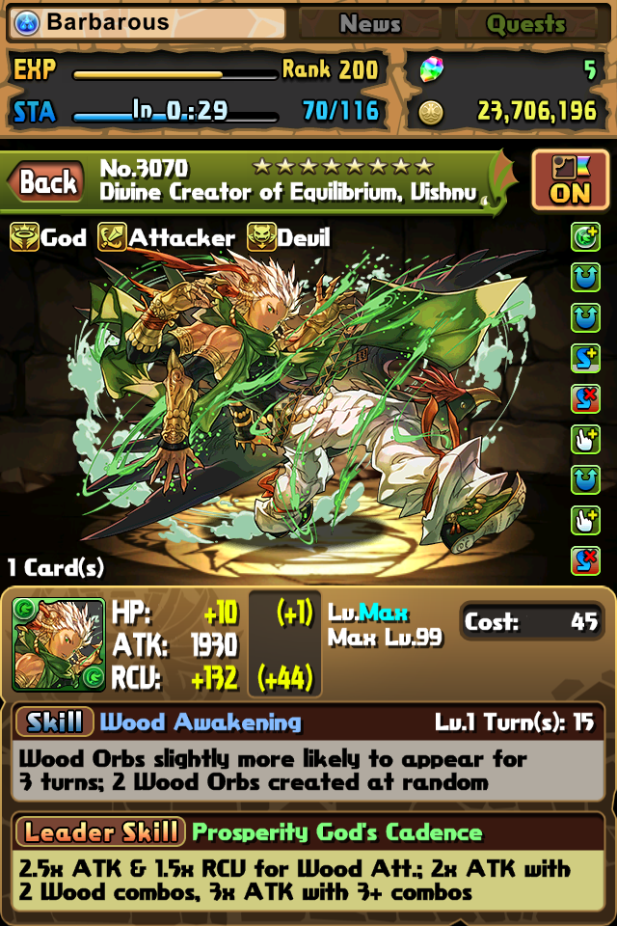

Monster ID

Rarity

Monster Name

Monster Types

Awoken Skills

Monster Stats

Current Level

Max Level

Team Cost

+ Stats

Active Skill

Leader Skill

Attributes

#### 1.3.1.1 Monster ID



The number that uniquely identifies a monster. It is a single non-changing value.

#### 1.3.1.2 Rarity



The numerical representation of a monster’s commonality. It is a single non-changing value.

#### 1.3.1.3 Monster Name



An unique alphabetical identification of a monster. It is a single non-changing value.

#### 1.3.1.4 Monster Types



Classifications of a monster. 1-3 non-changing values.

#### 1.3.1.5 Awoken Skills



Passive skills that need to be activated. 0-9 non-changing values.

#### 1.3.1.6 Monster Stats

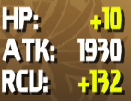

HP, ATK, and RCV. Values will change based on the monster’s level or experience.

#### 1.3.1.7 Current Level



The current level of a monster. Value will change based on experience.

#### 1.3.1.8 Max Level



The maximum level a monster can attain. A single non-changing value.

#### 1.3.1.9 Team Cost



The cost of the monster if used on a team. A single non-changing value.

#### 1.3.1.10 + Stats

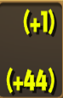

An increase to a monster instance’s base stats. Changes based if + monster are fused to the current monster.

#### 1.3.1.11 Active Skill

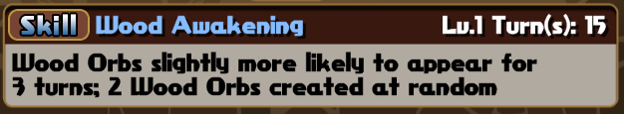

An ability a monster can have. Has a Name, Description, Current Level, Max Level, and a Cooldown.

* *Name: The name of the skill.*
* *Description: Explains how the skill works.*
* *Current Level: The current level of a skill.*
* *Max Level: The maximum level a skill can attain*
* *Cooldown: How many turns until the skill can be used. Is based off current level.*

#### 1.3.1.12 Leader Skill

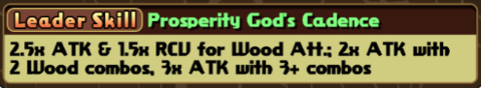

A passive ability a monster could have. Is only activated when the monster is in the leader slot of a team. Has a Name and Description.

* *Name: The name of the skill.*
* *Description: Explains how the skill works.*

#### 1.3.1.13 Attributes

 

The element(s) of the monster. 1-2 non-changing values.

### 1.3.2 Player

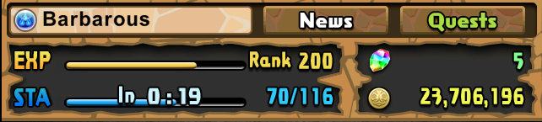

Player Name

Starting Attribute

Player Rank

Player ID



#### 1.3.2.1 Player Name



The name the Player chooses when account is created. Can be changed by the Player and does not have to be unique.

#### 1.3.2.2 Starting Attribute



The attribute of the monster chosen when Player created their account.

#### 1.3.2.3 Player Rank



The current level of the Player. Is determined by the amount of experience the player has accumulated.

#### 1.3.2.4 Player ID

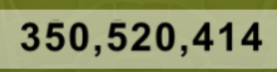

The number that uniquely identifies a Player. It is a single non-changing value.

### 1.3.3 Teams

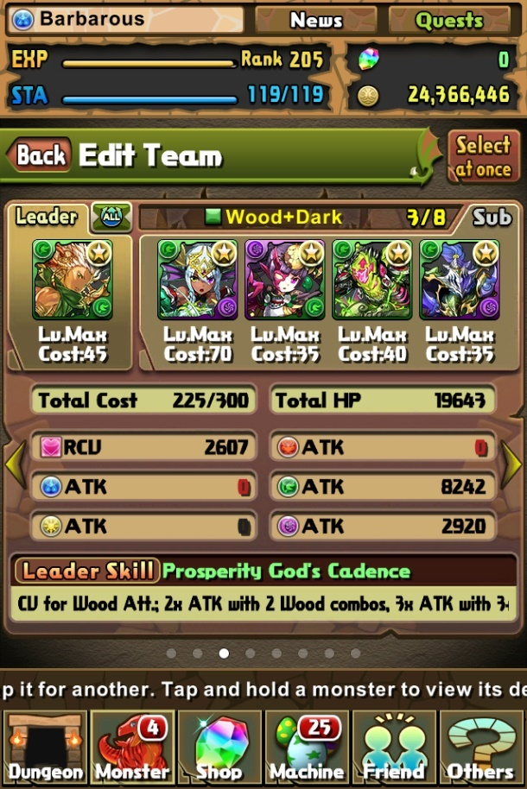

Team Leader

Team Subs

Team Name

Badge

Team Cost

Team HP

Team RCV

Team ATK

Leader Skill

#### 

#### 1.3.3.1 Team Leader

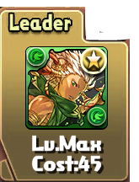

The only necessary monster on a team.

#### 1.3.3.2 Team Subs

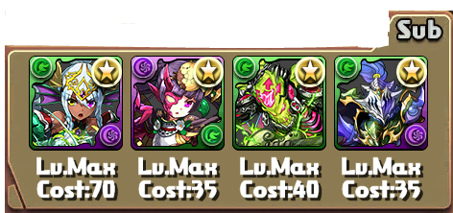

Additional monsters on a team.

#### 1.3.3.3 Team Name



A name given to a team by the player. Can be changed and does not have to be unique.

#### 1.3.3.4 Badge



A passive ability given to a team, unlocked through quests.

#### 1.3.3.5 Team Cost



The accumulated cost of all monster on the team, cannot surpass maximum Team Cost. Changes based on monsters on team.

#### 1.3.3.6 Team HP



The accumulated HP of all monster on the team. Changes based on monster on team.

#### 1.3.3.7 Team RCV



The accumulated RCV of all monster on the team. Changes based on monster on team.

#### 1.3.3.8 Team ATK

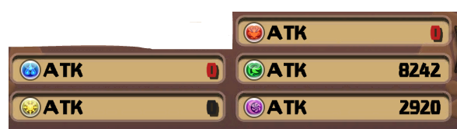

The accumulated ATK for each attribute. Changes based on monster on team and the attributes of the monsters.

#### 1.3.3.9 Leader Skill

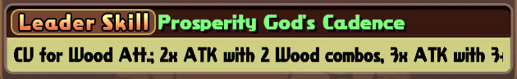

A passive ability a monster could have. Is only activated when the monster is in the leader slot of a team. Has a Name and Description.

* *Name: The name of the skill.*
* *Description: Explains how the skill works.*

## 1.3 Product Overview

The product will track all NA monsters in PAD along with all the other integral components required for a monster, allowing the User to create their own instances of monsters.

### 1.3.1 Product Perspective

Like PADX, our database keeps track of all of the NA Monsters as well as instances of user monsters and their teams. PADX also keeps track of the none NA monsters as well as dungeons, something we may add in the future.

### 1.3.2 Product Functions

* *Users will be able to enter their monsters, allowing them to track the progress of the monster*
* *Users will be able to create a “wishlist”, a list of monsters they would like to have or need*
* *Users will be able to create teams with their monsters and monster’s they don’t own*
* *Users will be able to select a monster and see it’s information at any level*

### 1.3.3 User Characteristics

Our Users will own a mobile device.

Our users will be players of PAD, all with differing experience with PAD.

### 1.3.4 Limitations

## 1.4 Definitions

Attribute: Element, a monster will have 1-2 of these.

Types: Monster Classifications, a monster will have 1-3 of these.

Active Skills: An ability a monster can have and use only after a set amount of turns, once used the amount of turns resets.

Leader Skill: A passive ability a monster could have, is only activated when a monster is set as a Leader.

Leader: The first and only necessary monster on a team.

Awoken Skills: Dormant skills a monster can activate when fused with the right monster, passive skills.

Fusion: An action that powers up a base monster using 1-5 other monsters, monster used in a fusion are lost.

Latent Skills: Passive skills given to a monster by fusing a specific type of monster to it, a monster can have up to 5 by default but an extra slot is currently able to be unlocked

Monsters: Cards, creature, characters.

Evolution Tree: The path of evolution a monster can take.

Evolution: An action that takes a base monster and up to 5 additional monsters and create the next/chosen monster in the base monster’s evolution tree, additional monsters are lost upon evolution.

Monster Instance: A monster owned by a user.

Team Instance: A team created by a user.

Team: 1-5 monsters used in dungeons to progress through the game.

+: An increase to a monster instance’s base stats.

# 2. References

* *Puzzle and Dragons, created by GungHo*
* *PADX -* <http://www.puzzledragonx.com/>

# 3. Specific Requirements

## 3.1 External Interfaces

### 3.1.1 Player

The User will be able to enter their PAD player information, where they will be able to update their information.

The Product will be able to display a User’s player information on command.

### 3.1.2 Instance of Monsters

The User will be able to enter their monster information into the product, where they will be able to update or delete the monster at will.

The product will be able to display Users monsters upon command.

### 3.1.2 Teams

The User will be able to create teams, using existing instances of monsters and monster default information.

The Product will be able to display a User’s teams on command.

## 3.2 Functions

### 3.2.1 Attribute Table

* *Admin will insert initial data*
* *Admin will be able to update table if there are any changes or additions*
* *Database will be able to display information*

### 

### 3.2.2 Monster Type Table

* *Admin will insert initial data*
* *Admin will be able to update table if there are any changes or additions*
* *Database will be able to display information*

### 

### 3.2.3 Awoken Skill Table

* *Admin will insert initial data*
* *Admin will be able to update table if there are any changes or additions*
* *Database will be able to display information*

### 

### 3.2.4 Awoken Skill List Table

* *Admin will insert initial data*
* *Admin will be able to update table if there are any changes or additions*
* *Database will be able to display information*

### 

### 3.2.5 Latent Skill Table

* *Admin will insert initial data*
* *Admin will be able to update table if there are any changes or additions*
* *Database will be able to display information*

### 

### 3.2.6 Active Skill Table

* *Admin will insert initial data*
* *Admin will be able to update table if there are any changes or additions*
* *Database will be able to display information*

### 

### 3.2.7 Leader Skill Table

* *Admin will insert initial data*
* *Admin will be able to update table if there are any changes or additions*
* *Database will be able to display information*

### 3.2.8 Monster Class Table

* *Admin will insert initial data*
* *Admin will be able to update table if there are any changes or additions*
* *Database will be able to display information*

### 

### 3.2.9 Badge Table

* *Admin will insert initial data*
* *Admin will be able to update table if there are any changes or additions*
* *Database will be able to display information*

### 

### 3.2.10 Evolution Tree Table

* *Admin will insert initial data*
* *Admin will be able to update table if there are any changes or additions*
* *Database will be able to display information*

### 

### 3.2.11 Player Table

* *Users will insert their individual data*
* *Users will be able to update their information if there are any changes or additions*
* *Database will be able to display a user’s own information*

### 

### 3.2.12 Latent Skill List Table

* *Users will insert their individual data*
* *Users will be able to update their information if there are any changes or additions*
* *Database will be able to display a user’s own information*

### 

### 3.2.13 Monster Instance Table

* *Users will insert their individual data*
* *Users will be able to update their information if there are any changes or additions*
* *Database will be able to display a user’s own information*

### 

### 3.2.14 Team Table

* *Users will insert their individual data using their existing information from the monster instance table*
* *Users will be able to update their information if there are any changes or additions*
* *Database will be able to display a user’s own information*

## 3.3 Usability Requirements

## 3.4 Performance Requirements

## 3.5 Logical Database Requirements

## 3.6 Design Constraints

## 3.7 Software System Attributes

### 3.7.1 Reliability

Information is up to date.

## 

## 3.8 Supporting information

# 4. Verification

# 5. Appendices

## 5.1 Assumptions and Dependencies

### 5.1.1 Assumptions

* *Users will be players of PAD and understand what they require to successfully enter their monster instances*

## 5.2 Acronyms and Abbreviations

HP: Health Points

ATK: Attack

RCV: Recovery/Receive

PAD: Puzzle and Dragons

NA: North America